Onur Ereren

Omer Faruk Gokbak

HRISTO PAVLOV

December 6, 2019

GROUP1-Project Analysis Document

Table of Contents

**Project Analysis** 2

**Stakeholders of the project** 2

**Targeted Users** 2

**Identification of the problems which are faced in Student Housing B.V and possible solutions** 3

**Project Deliverables and Timetable** 5

## **Project Analysis**

### **Stakeholders of the project**

* Administration Office

(which is responsible for the registration of new clients)

* Student Community

(The platform that Students can announce their parties, gatherings and events.)

* Controlling Community

(which is responsible to check the announced people whether they have done their tasks.)

### **Targeted Users**

The targeted end-users, we are aiming to satisfy, are the students accommodated by Student Housing BV, who struggle with managing their tasks with their roommates.

### **Identification of the problems which are faced in Student Housing B.V and possible solutions**

**Problems faced:**

* Sometimes, the appointed person does not clean the place/ show up which is his responsibility.

* Students organize parties or meetings without any announcements. It causes extra crowded and mess in the building such as events can coincide with each other at the same time.

* The garbage collector does not show up, therefore pending garbage causes bad smell and also visual pollution.

* Grocery shopping and payments for that are not done in a timely manner.

**Solutions are approached by our Developer Group:**

We will deliver a Windows Form Application that keeps track of the completed and upcoming house-tasks. It will also distribute the costs for the common items and notify us of upcoming events in the house.

**Solution for Appointed persons are not cleaning; Garbage disposal is not done:**

When someone finishes with cleaning/garbage they’ll simply record it on our application. If someone didn’t mark a task as complete in time, the application will display a message about it. After the student has marked a task as complete, the other person, we have assigned, will check whether the work has been done or not.

**Solution for Groceries are not done/paid for:**

Every time the user has bought something for common use, they will input in our application the item and its price and our application will distribute the costs among everyone in the house accordingly and display who owns whom how much for what. If someone didn’t buy/pay for something on time, the application will display a message about it.

**Solution for Unannounced parties, gatherings, etc.:**

We will deliver a list, for the upcoming events, which we will be able to Read/Update when necessary. If we are having a party at the house later that day, thanks to this list, we can inform everyone about it, as soon as we can.

### **Project Deliverables and Timetable**

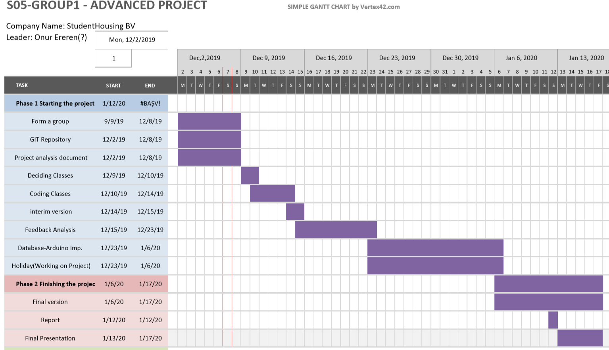

Figure 1- Project Timetable

It can be seen from the above, Figure 1 is the example timetable that our team should be following. However, Our team aware of that there will be some difficulties faced during following this timetable. Therefore, the timetable can be changed slightly over time.

### **Possible dependencies may impede the process of your project**

* Appointed Employee did not check the kitchen or toilet cleanliness.
* Students did not follow the house rules. (cleaning the shared facilities or throwing garbage)
* Sensors/Detection systems stopped working. (For example-> Arduino)

**Possible solutions:**

* More people can be employed for checking kitchens and toilets or Some simple sensor systems can be used while there are no employees around.
* Students can be fined If they do not follow the house rules.
* Some employees can be assigned until sensors are fixed.